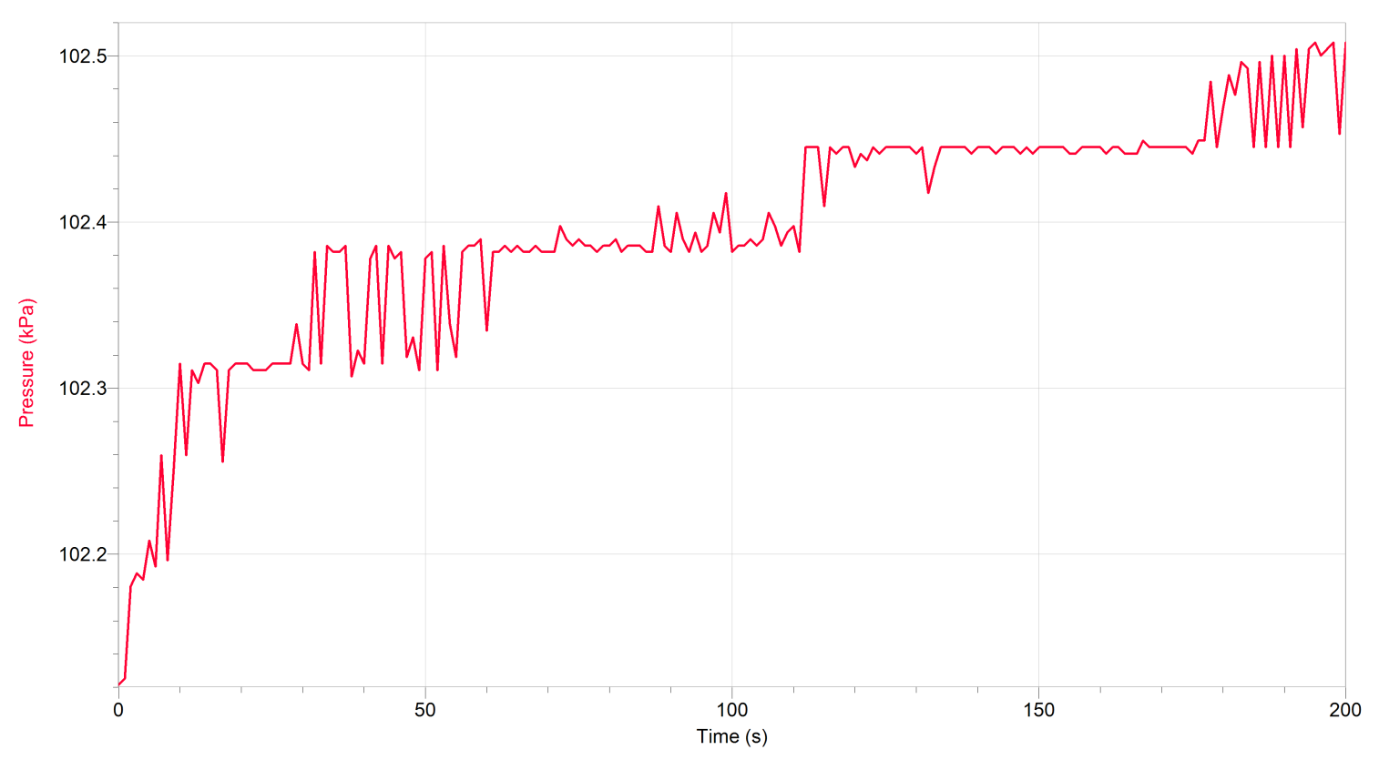
Catalase, Hydrogen Peroxide, and pH 7

Catalase, Hydrogen Peroxide, and pH 3
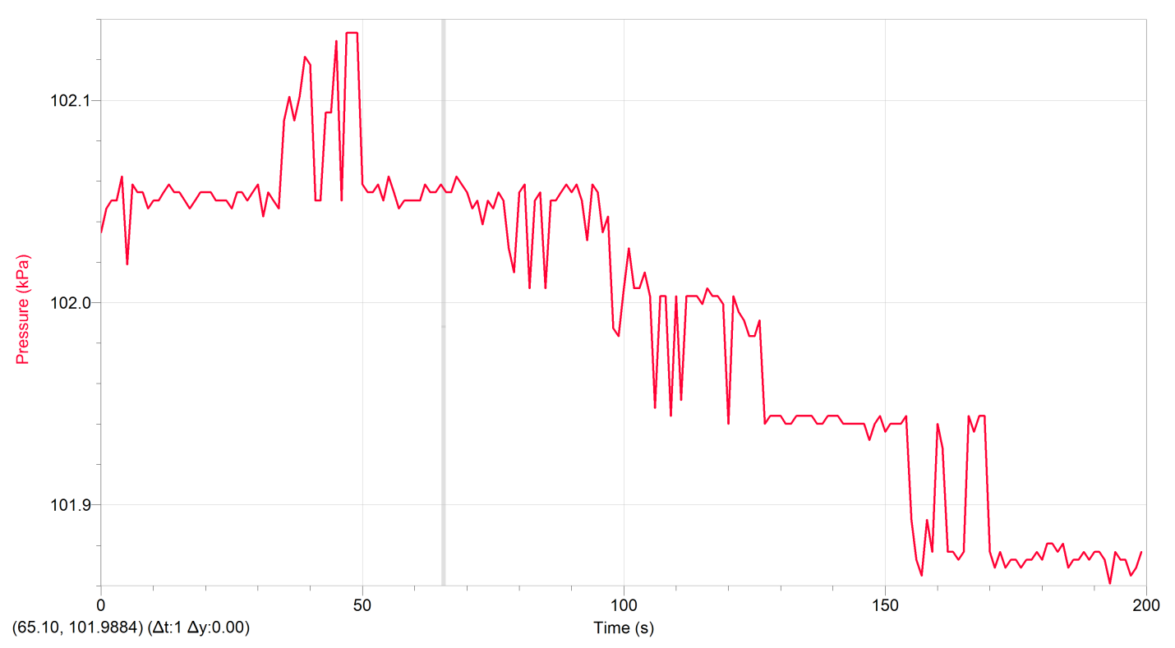

Catalase, Peroxide and pH 9
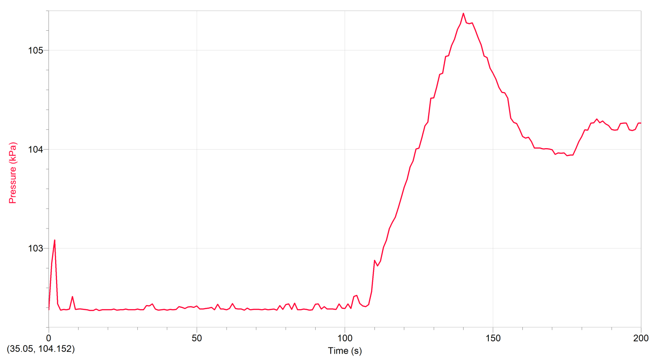

Catalase and Hydrogen Peroxide
